## 

## 





|  |  |  |
| --- | --- | --- |
| http://www.cmaa.gov.kh/img/donor/1421124070.png | http://upload.wikimedia.org/wikipedia/en/2/2b/Logo_unifr.jpg |  |

## ***The project***

The Impact of the Socio-economic Structure of Rural Population on the Success of Rural Development Policy” is a research –based, policy directed regional project, between the Association of Agricultural Economists of the Republic of Macedonia and the Public Policy research Centre (CENTAR) from Serbia, engaging researchers from Macedonia, Serbia and Bosnia and Herzegovina. It is funded by the Regional Research promotion programme in the western Balkan and the University of Fribourg, both administratively and as mentoring institution.

Rural areas of Macedonia, Serbia and Bosnia and Herzegovina face common problems typical to the transition countries, such as: intensive depopulation, low activity on labour market, slow process of farm restructuring, high share of small and semi-subsistent farms with mixed income.

Agriculture is the main source of income in the rural areas, but since it is characterized with small farms with low level of productivity, many excluded from the commercial agro-food chain, it does not ensure sustainable livelihoods for farm households.

The low level of support for rural development, which does not address enough the problems in rural areas, is just one of the problems that farmers face. A large number of them are not familiar with the measures and mechanisms of support for rural development, and a significant number cannot meet the administrative requirements (e.g. evidence proving property rights, collateral etc.) or deal with the complex rules and procedures to access budgetary support. Insufficient preparedness of farmers and institutions to meet the provided rules results with a low rate of utilization of the planned budgetary support.

One way to increase the absorption capacity is by supporting farmers in their intention to improve the farm capacities, to enhance the environment and the rural economy. Furthermore, by establishing and maintaining effective institutional framework (sufficient institutions and organizations in rural areas, both public and private actors, which are well developed, skilled and motivated to support farmers) can additionally contribute to the use of opportunities and hence provide a more dynamic restructuring of the sector.

The overall goal of the project is to support the socio-economic development in rural areas by increasing the absorption of the rural development funds and increasing the economic networking of farmers; thus increasing the effectiveness of the rural development policy instruments. In that regard, the project defines few objectives: (1) to understand the socio-economic characteristics of rural areas, (2) to understand the motivational factors and barriers of farmers, as major part of rural population, to apply for RD support or (3) to take part in formal organizations, and (4) to understand the informal networks organization and structure.

The research is based on comprehensive analytical approach, applying two well applied theories – the Theory of Planned Behaviour and the Social Capital theory – on data collected in a survey that took place in November- December 2014, simultaneously in the three countries – Macedonia, Serbia and Bosnia and Herzegovina – covering 300 farming households in each country. In each country, two different regions were observed, one having an operational network organization and one without. In Macedonia, it is Strumica village Kuklish with the cooperative Vegefresh and 12 villages in Bitola surrounding without cooperative.

## *Problem: Low level of RD support*

The total budgetary support to agriculture and rural development, as well as the share of structural and rural development measures within, is relatively low and unstable in comparison with EU average. The data for 2012 (calculated based on realized budget per policy measures, according to the Agricultural Policy Measures template) shows that budgetary support amounted about EUR 150 per hectare of UAA. The level of budgetary funds for structural and rural development support is about EUR 25 per hectare of UAA with some fluctuation through the years in terms of measures applied and amount of funds. Considering the available agricultural land area, this reflects the limited potential to address development issues with these funds.

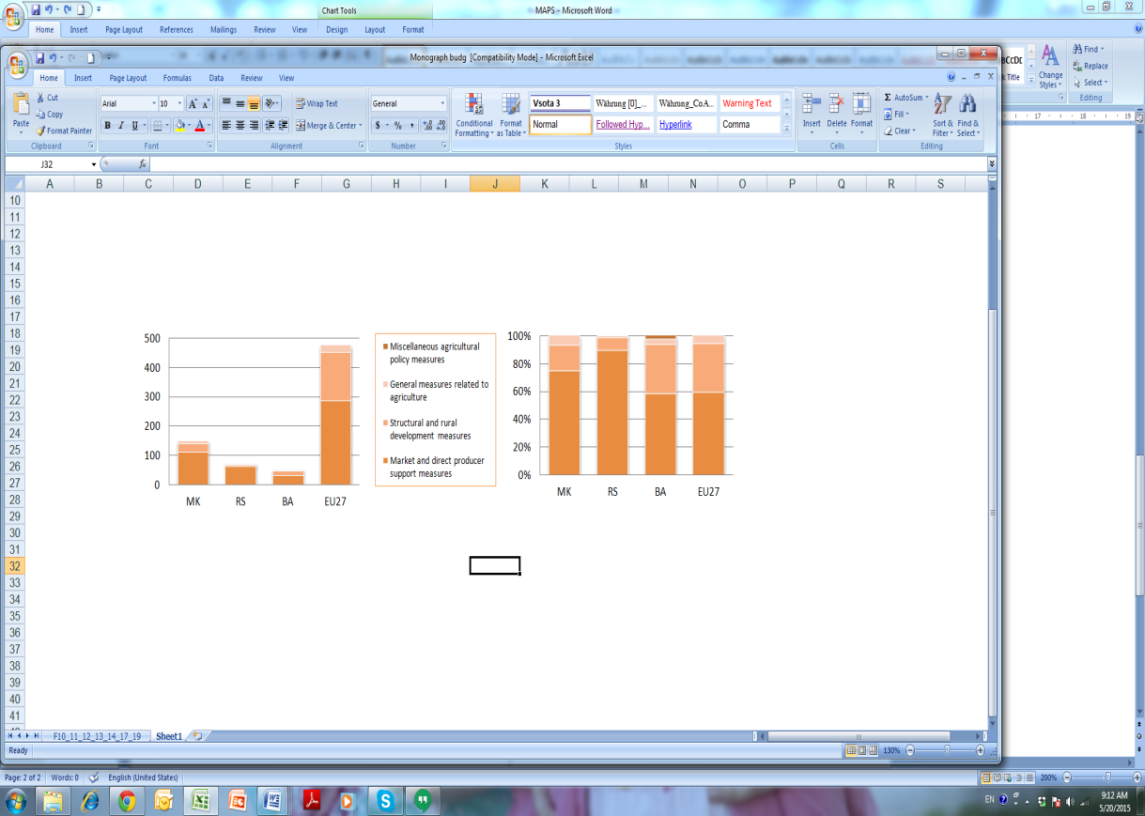

Figure 2: Budgetary expenditure for agri-food sector and rural areas, by pillars, 2012 (million EUR and %)

On-farm investment support for improving the competitiveness of agriculture (Axis I) dominates in the structure of rural development support. Funds intended for improving the environment and the countryside are minor, which is challenging question from the perspective of balanced territorial development.

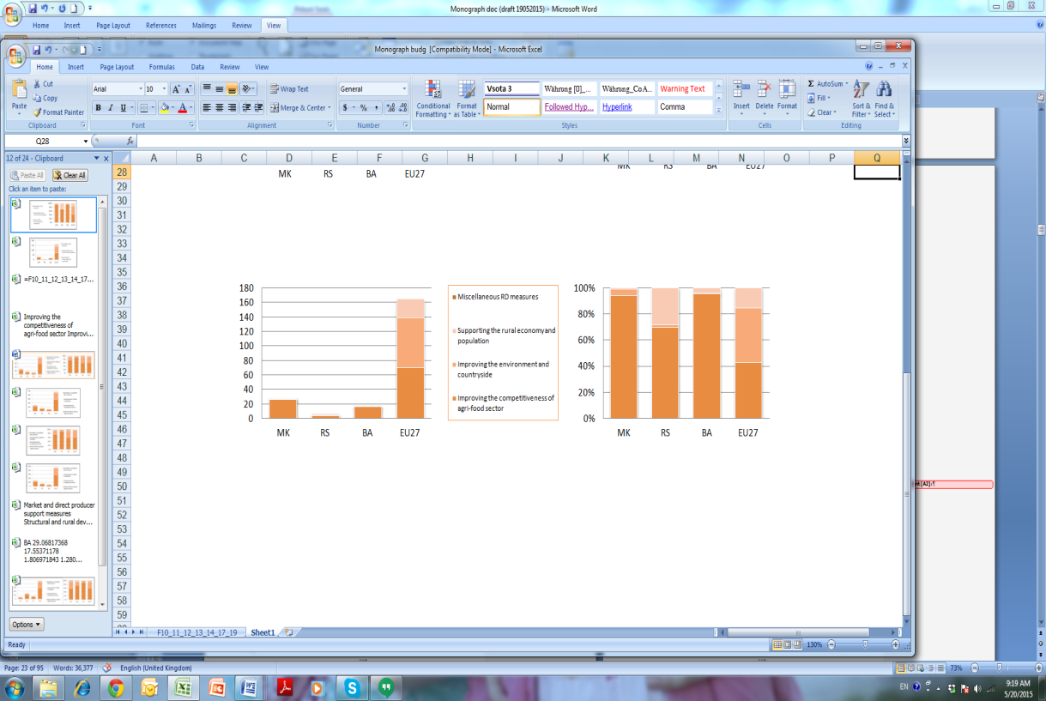

Figure 3: Budgetary expenditures for structural and RD measures, by axis, 2012 (million EUR and %)

Funds for supporting rural economy and population are also rather weak, although it includes some infrastructural projects in rural areas, investments for on-farm diversification of economic activities, as well as improvement of social networks, establishment of local action groups and local/regional partnerships.

## *Recommendations*

* An appropriate strategy for rural development is needed to keep the rural population in the villages. Joint and coordinated activities of various governmental structures (ministries and agencies dealing not just with agriculture, but also with education, infrastructure, economy, social services, labor etc.) are needed to overcome the heterogeneous and complex issues of rural development. The development problems of rural areas and their backwardness must be positioned on higher level on the agenda of national governments and become cross-cutting issue in order to stop and prevent their further degradation.
* Policy decision makers have to create more stable predictable policy framework and then implement what they already adopted. Although support to agriculture is the key activity and source of livelihood of the rural population, the present productivistic orientation should be avoided, since there are other policy objectives of equal importance for rural population and wider society. This primarily refers to investments in farms, environmental issues, poverty, integration of newcomers, survival or transformation of small farms, social structures of rural society etc. The need for funds for RD support has been recognized, but the share and amount of budgetary transfers for rural development should further increase.
* The decentralization as a key principle in the creation of rural development policy requires strengthening the capacity of stakeholders to participate in this process. Efforts in this direction must be ongoing and include widest circle of participants. Therefore, a variety of information campaigns, promotional activity and awareness raising operations are needed in order to reach critical mass of local actors.
* Local municipalities should put effort to promote the opportunities to rural population, to recognize their needs, and to improve their human and material capacities in order to employ those opportunities. One way, is using the LEADER approach by formation of Local Action Groups and their capacity building.
* Important partners of both the government and farmers are producers' associations, cooperatives and NGOs. These institutions, in addition to carry out the transfer of knowledge and information, should take on the role of lobbyists for the interests of farmers and rural communities. Strengthening their capacity, their horizontal and vertical networking with other actors, as well as building mutual trust and shared commitment to work on common goals, is a long-term process that requires resources. Local communities must support their activities and these developments, as part of the efforts to build social capital.
* Improvement of the age structure in rural areas should be high on the priority list of the rural development policy. Measures such as additional support to young farmers or early retirement schemes can encourage transfer of the farm (which would in turn solve many of the property-right issues and ease the application procedure) and can further contribute to increased entrepreneurship, introduction of innovations, modernization of the farms etc.
* Strengthening the resilience of smallholder farmers operations requires coherent policy framework and adaptive coping measures that could compensate the small sized agriculture and increase market exposure. Diversification of economic activities in rural areas should increase the employment opportunities and the source of income, subsequently improving the living standard and the quality of life in rural areas.
* The acceleration of structural reforms is needed in order to create conditions for faster and more efficient redistribution of resources towards larger and more efficient producers. This can be achieved by support for activation of land market operations, land management, land consolidation, technology transfer, farm modernization, strengthening of food chain and access to the financial market.
* Improved access to diverse sources of finances (bank or informal credit products) is imperative. Government could support this by developing mechanisms such as guarantee funds, as well as to encourage banks to intensify their involvement in rural crediting and investments in rural areas. Another possibility is a creation of a formal platform group of financial institutions, providing innovative and tailored financial products, for all stakeholders (producers, processors, buyers etc.).
* Policy implementation and impact assessment by using comprehensive tools enables evidence-based policy making, but it strongly depends on the institutional capacities and requires continues strengthening. This applies equally to intensify the analytical capacity of the research community, the application of modern scientific methods and tools for policy driven applied research.
* Action regarding simplification of the application process and documentation, could additionally contribute to easier and more successful realization of the RD policy. This requires reforms in a number of institutions, both those that assist farmers in preparing, and those that handle their applications.

## *Problem: Lack of data for rural areas*

The research faced lack of data concerning rural areas; those available are often not comparable, nor compatible. Partly, this is due to the different definitions of rural area and rurality, as well as due to the not fully harmonised national statistics with Eurostat.

The rural areas are defined in the Law of Agriculture and Rural Development (MAFWE 2010), according to which rural areas are municipalities in which all settlements have less than 30,000 inhabitants or population density is less than or equal to 150 inh./km2 of the municipality area.

The State Statistical Office produces data on rural area based on criteria from the Law on Territorial Organization (2004) defining cities and villages, based on population size, infrastructural development and share of the primary sectors in employment, which is quite a different approach.

There is no official number of rural area and population, neither available data on area and population size per settlement, but at municipality level. If calculated at municipality level, by the criteria by defined in Law on Agriculture and Rural Development (MAFWE 2010), total rural area covers 88.7% of the territory of Macedonia (including 62 municipalities), which is a home to of 985 thousand citizens or 47.3% of total population. In practise, some of these municipalities include cities, which should be excluded from the calculation, thus reducing the share of rural area and population.

The large share of rural areas and rural population put an additional weight on the need for the rural development policy.

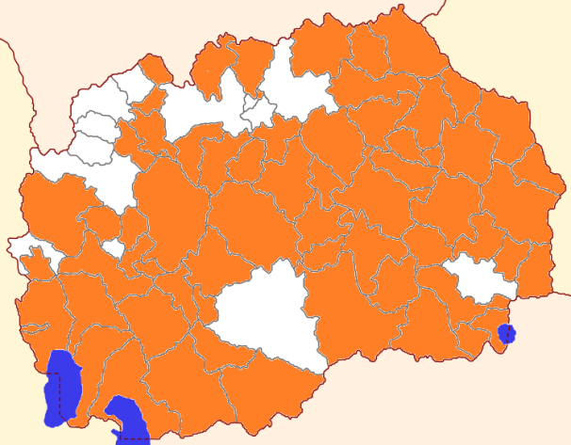

Figure 1: Rural area of Macedonia (coloured orange)

## *Recommendations*

* Special emphasis should be put on developing and strengthening of the statistical systems in providing nationally and internationally consistent, cohesive and comparable indicators that reveal the real situation in rural areas and the impact of the applied public policies, including the rural development policy. The national statistical offices should provide more information on diverse aspects of rural areas as a key element supporting the process of rural development policy making. The definition of rural area should be harmonized within the national legislative and appropriately transferred in the national statistics.

## *Problem: Low participation in formal organizations*

Farmers find membership in formal organization (such as cooperative or professional association) very useful. This is especially pronounced among those who are members of an organization, which indicates that these institutions succeeded to justify the trust of their members. However, difference between attitude and current behavior is observed, thus actual farmers’ participation in such organization is very low.

There are several major reasons behind low membership rates. The most important obstacle hindering farmers’ involvement in organization is lack of active organizations and lack of information about them. Accordingly, the lack of membership experience results in not recognizing the benefits of being members of an organization. In addition, many farmers believe that membership is time consuming, while some have distrust in such organization.

Personal affection, cooperation benefits and overall functioning of the organizations’ management are not perceived as barriers by farmers to become members. Such findings raise optimism regarding the possibility to see a change in farmers’ behavior in the near future through their involvement within existing, but also new organizations in rural areas of the respected countries.

The research confirms the presence of partially functional farmer’s informal networks in all countries, usually built on strong personal bonding ties. The generated networks are characterized with low level of social capital and trust. In regions with an existing functional organization, information is more concentrated between fewer actors.

This networking of farmers increases their ability to obtain and share resources embedded in socio-economic network (especially information, knowledge, finance etc.), which do exist, but are poorly developed.

## *Recommendations*

* There is obvious need to promote and support networking activities of local rural population. Development of efficient and diversified social networks in rural areas should be high on the policy agenda. New innovative networking strategies, which are sensitive to the social context and individual capacities, motivational and behavioral determinants, can contribute to that effect.
* The strategies to promote cooperation should take into consideration the observed mismatch between the positive attitude toward organizations and the actual behavior. They should be based on farmers’ personal motivation built upon positive membership experience, positive attitude towards usefulness of organization and their contribution to public interest, and capabilities to ensure good and fair relationship, while preserving the personal integrity.
* Intermediate organizations that are well socially embedded and able to recognize the needs of local population could support cooperation management and retain knowledge and experience raised by the networks. Such organizations could ensure better targeting of RD policy and be used as platforms from which local accountability may be demanded and guarded, as a prerequisite to increase general trust and culture of cooperation.
* Critical factor for well-functioning and sustainability of farmers’ organizations, including cooperatives, are the managerial skills of the organization’s executives, their ability to respond to a volatile business conditions, find new markets and market niches. Additional incentives should attract educated, ambitious and skilled persons to engage in such position.

## *Problem: Observed need and barriers to apply for RD support*

Farmers expressed willingness to invest, to apply and co-finance RD projects in accordance with their determination to stay in the agricultural sector. Farmers’ intention to apply for RD support is influenced by their attitude, the importance of social approval, (dis)ability to prepare applications and limitation factors related to co-finance and access to information.

Over 90% of surveyed farmers in all countries have positive attitude toward rural development policy, declaring it is good to have RD support. Most farmers in all three countries positively assess the RD support for personal benefit (improvement of their own farms), but are less aware of the opportunities that RD brings for public benefit (improvement of infrastructure, protection of environment and acceleration of development of rural areas). The contribution of RDP for sustainability of family farms and increase of their income are perceived as biggest advantages of RD support.

Family and peers are important to farmers. Farmers who positively evaluate the significance of the RD support, and who have more support from other people, have stronger intention to use the RD support.

The farmer’s personal abilities (knowledge, experience, preparedness, own financial capacity), as well as the access and cost of RD support application (information, procedure and documents) are perceived as barriers.

National extension service and media are recognized as the most important most important providers of information and services. Extension agents are especially appreciated, while farmer evaluate government and formal organizations as weak source of help and advice for RD support. Access to information through NGOs, cooperatives and professional organizations is better in the regions with existing functional organizations.

## *Recommendations*

* Adjustments in attitudes towards the agricultural occupation are needed. The slow process of change of ownership structure suggests that the farm is seen as a family asset, rather than a workplace and economic system that persist on market principles. Transfer of property rights to young farmers could contribute to their inclusion in agricultural activities at earlier age, stimulating greater commitment, readiness for strengthening skills and long-term investment, hence raising competitiveness.
* The European rural policy has a more holistic framework with strong focus on the farmers' welfare as providers of public goods and broader interests of society. Farmers in the Western Balkan countries are still at a stage where economic motives are underlying drivers of their activities. Apart from their personal benefit, it is necessary to raise the awareness about the public benefits for enhancing the quality of life in rural areas and subsequently to increase the willingness to participate in such projects. An issue remains, that actually such sophisticated support measures are still not available.
* There is substantial room for improving farmer’s understanding of RD policy, its general framework, procedures and required operational rules (co-financing, acquiring minimum standards etc.). In this respect, the self-initiative of farmers, their entrepreneurial spirit and commitment to improve their operations are main preconditions for overcoming the vulnerability of family farms, hence reaching competitiveness and sustainability. The adoption to the new entrepreneurial mentality is a challenge for the farmers in Balkan countries, accustomed to the state controlled regimes and systems of support. These processes take long temporal dimension and require efforts of the wider society to facilitate farmers’ adaptation to the values of resilience and sustainability.
* Due to the importance of informal social networks, it is valuable to identify the potential “agents of change”, “village leaders” or “information brokers” to encourage the desired behavior. Such persons, widely respected by their peers, can facilitate the promotion of the program, motivate and support others to apply to RD support. Strong awareness/information campaigns can supplement the development and use of such new innovative information channels.
* The use of RD support can be enhanced by sharing the experience, lesson learnt, and success stories between farmers and among cooperatives at regional and national level. Having in mind the common background, similar mentality and local culture, farmers can exchange the experience even between their peers in the other Western Balkan countries.
* The lack of knowledge and information of farmers as target population, should be overcome with a well-structured agricultural knowledge transfer system (AKIS), built on functional and efficient linkages between knowledge generation institutions, extension service providers and farmers. The AKIS should include private and public institutions, both those that operate on a commercial basis and those funded by state. The training modules and modalities of knowledge transfer should be tailor-made according to the needs of producers.
* Operational extension support and advisory network is vital in communicating the rural development policy to the target beneficiaries. Additionally, there is growing need for efficient and competent assistance supporting them in the application process. In order to ensure the well-functioning of this segment, there is continuous need for stable financing, capacity building in terms of human and material assets and enhanced field work.

More information in Kotevska A., Martinovska Stojcheska A. (eds.). 2015. The impact of socio-economic structure of rural population on success of rural development policy. Skopje: Association of Agricultural Economists of the Republic of Macedonia (available in print and digital at www.zaem.mk)